**Essay / Assignment Title:** Designing a sales dashboard in Tableau for a chosen company

**Programme title:MSc of Data Analytics**

**Name: Turan Can Gün (Q1055616)**

**Year: 2024 (2023 Intake)**

**CONTENTS**

INTRODUCTION 4

CHAPTER ONE Definiton of Target Audience - KPIs and Expectation 5

CHAPTER TWO Identification the Problem 6

2.1 Specify the Problem 7

2.2 Role of Data Analytics 7

CHAPTER THREE Finding Solution 8

CHAPTER FOUR Dashboard Design 10

4.2 Explanation of Dashboards 16

CONCLUDING REMARKS 21

BIBLIOGRAPHY 22

APPENDIX (if necessary) 23

**Statement of compliance with academic ethics and the avoidance of plagiarism**

I honestly declare that this dissertation is entirely my own work and none of its part has been copied from printed or electronic sources, translated from foreign sources and reproduced from essays of other researchers or students. Wherever I have been based on ideas or other people texts I clearly declare it through the good use of references following academic ethics.

(In the case that is proved that part of the essay does not constitute an original work, but a copy of an already published essay or from another source, the student will be expelled permanently from the postgraduate program).

Name and Surname (Capital letters): TURAN CAN GÜN

.......................................................................................................................................

Date: 28 / 10 / 2024

# **INTRODUCTION**

As countries of our world is connected to each other by technology in that case everything starts more digitally including trading.Moreover trades between countries are standardized with General Agreement on Tariffs and Trade by World Trade Organization (WTO) in 1947 ( Baldwin, Richard. 2016 ).As trade is digitalized demand for products are increased so business requires the digital analysis to handle their situation based on financial , marketing , customer experience and so on.Reason of using digital analysis is related to high demand for products since high demand means potential database isn’t appropraite across manual analyse.Manual analyse isn’t possible theorotically also waste of time.

In this study will be introduced to Key Performance Indicators (KPIs) also role of a data analyst will be elobrated in this context then possible solution ways are going to explored.After that practical steps are going to handled by using appopraite suitable business analyst solution.

# **CHAPTER ONE Definiton of Target Audience - KPIs and Expectation**

Audiences might be sales managers , executives and other technical analysts for sales performance progress.However if there is a need regarding to sales performance in terms of financial situation sales managers can be good option for this target.Although executives are interested on that context still they have more interest on general financial outlook all whole company.In this case the target audience is sales managers..

KPI ( Key Performance Indicator ) is a metric wihch measures progress of specific business needs in businesses.This metric is critical because organizations are able to assess their performance results across their business targets (Domínguez et al. 2019).Moreover KPI isn’t just benefitical for existed business also that can provide hard fundamental during the design stage of prospective corporations (Heikkilä et al. 2016; Gilsing et al. 2021b).

As mentioned before KPI is able to display progress across achieved goals.This feature is useful to unify employees within in a business in terms of engagement since organizaitons struggle with this concept.Furthermore as engagement increased customer satisfaction for a company go up.Although KPI is a well indicaitor for businesses , KPI must be integrated into business goals as well as satisfaciton of employees.

Basically there are 5 types of KPIs also these types are can be explained ;

1. Sales KPIs measure sales performance also track the performance.Its metrics are revenue , purchase value , retention rate and so on.
2. Marketing KPIs that can be understood from the name which evaluates marketing campaigns.Parameters are number of website visitors , socail media engagement etc.
3. Financial KPIs aim to identify monetary output like revenue growth, profitability, return on investment (ROI) with stability.
4. Operational KPIs are related to more technical side since measurements are production output and quality control.
5. Customer KPIs interest across customer satisfaction , expreience and more.

Typical KPIs must have some standardized fetures such as business aligned , actionable , realistic , measurable.Business aligned is each sub deparment of a company should identify their specific goals.Actionable means the way must be clear to realize any specific goals then realistic indicates goals must be compatible in terms of input and output of a business.Measurable is the way to measure success of KPIs such as business analytics tool PowerBI , Tableau.

In real life applications to monitor goals there are mainly two ways.First one is classical method that is called as spreadsheet other one visualization tools like Tableau.Although to use spreadshhets might be easier they required manual data entry on the other more advance tools are able provide real time data flow from data source as well as adapt new updated goals.At the same in recent years these advanced tools have been started inegrated into artfitical intelligence technology to increase productivity and accuracy.

In this study the scenario likes assume that there is there is a market and its product contains from technological devices to stationery and furnished goods it means there is a very broad range in terms of diversity.Main goal can be considered extracting meaningful insights from the dataset regarding to finanacial , supply chain , customer demography , and regions based on this explanation.After that step the expectation is optimizing many parameters like financial – production efficiency and customer satisfaciton for future years.

# **CHAPTER TWO Identification the Problem**

## **2.1 Specify the Problem**

For this study the problem will be based on multiple factors such as ;

* Customer Segmentation : Explaration of customers based on their various features like demographics , purchase behaviour or their preferences.
* Sales Prediction : Prediction of sales patterns across years , supply chain types , regions and so on.
* Trend Analysing : Extracted information from sales insights can be useful to understand preferences of customers towards to country , region etc.
* Performance Monitoring : As well as sales performance and trend analysing general consideraiton should be monitorizing specific KPIs to achieve pre defined business aim.

## **2.2 Role of Data Analytics**

In general perspective an analyst defines the problem , trying to find possible solutions by using vairous tools and models then apply selected solution at the final step who concludes extracted insights.Moreover with this definiton the role can be elobrated in terms of business intelligence (BI) solutions with these advantages ;

First of all business intelligence solutions like PowerBI and Tableau are able to provide information about current situation of stocks , sales statistics , new customers and so on.Secondly these tools has a feautre which is related to extracting hidden patterns , correlations among variables of selected dataset.At the same time tools are able to set ligh to future by using forecasting technique.Thirdly in terms of socially from analyses customer (purchase) behavior can be obtained to tailored aims across specific groups and regions.However to before realize all these factors there are some technical steps must be handled ;

1. In real life applications various datasets might entails some inconsistent and unappropraite variables or null features so this situation leads to reduced accuracy as well as untrustful insights then to be avoid from this issue datasets must be checked and cleaned if there is a need.,
2. Features or dimensions of any dataset must be demosntrate before analysing step. This stage might help to understand fundamental knowledge of dataset also which takes a role as an accelerator to identify either aims or goals.
3. Segmenting of attributes of dataset is crucial to demonstrate hidden patterns.Actually this is pre stage before dashboard.
4. Visualization is last step which includes to using of different charts then conclude with a dashboard but a dashboard should have appropraite format , colours and size.

When these steps are handled effectivley this situation not just leads to useful insight also which set up light to prospective years.

# **CHAPTER THREE Finding Solution**

To solve business analytics problem there are 2 most popular tools they are PowerBI and Tableau.PowerBI is developed by Microsoft and Tableau is developed by Salesforce company.Each of them has specific targets as a result of that these tools must be compared.

|  |  |  |
| --- | --- | --- |
| Feature | Tableau | PowerBI |
| Usage Area | Customer segmentation , sales analysis | Same area as Tableau integrated with Microsoft |
| Analysis Capacity | Compherensive data analysis and various visaulizaitons options with real time from multiple data sources. | Solid integration into Microsoft instrumentation with cheap prices. |
| User Experience | Drag-drop option , pre-defined visualizaitons and recommendations for dashboard | Same properties additionally access to Micrososft products |
| Data Transform | It provides feature to cleaning and transformation even in complex level | Data transformation is available by Power Query and Power Pivot |
| Potential Audience | Dashboards can be filtered based on country , region , products ,age and so on. | Solid capability with Microsoft Office 365 to common share in employees |
| Mobility | It supports for real time flow | It supports real time flow also offline access to some properties |

Table 3.1 Comparision of Tableau and PowerBI ( VV Dogadina et. al , 2023 )

In this study Tableau is used.Both tools are able to provide data transformation by using various sub features Power Query and Tableau prep for PowerBI and Tableau respectiely.Moreover if an organizaiton uses Microsoft services PowerBI might be better options otherwise Tableau.However if the context is data exploration Tableau is better option than PowerBI.In shortly the preference depends on data size , organziaton products.The analysis process is handled data preparation (cleaning) , exploring dimensions of selected dataset then analysing pattern by using various charts then at end of the day dashboards are used to conclude all extracted insights.

# **CHAPTER FOUR Dashboard Design**

In that stage there are 5 different dashboards to visualize various patterns among the dimensions of the dataset.Moreover here the dataset is examined by various aspects such as from number of stocks of goods to financial gain from each region as well as variations by different years.Before handle dashboards one by one each sheets will be demonstrated.

**4.1 Explanation of Sheets**

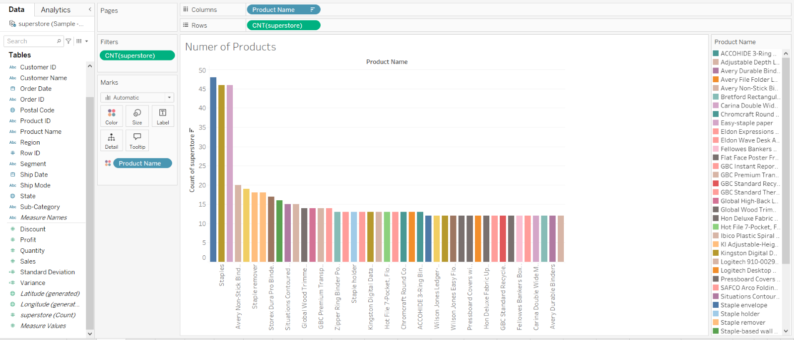Figure 4.1 Number of Products

In Figure 4.1 which demonstrates number of products in this sheet filter is used since there are too much number of type of products to visualize them and not efficient way.Therefore filter is applied to show just number of products between 12 – 48 at the same time each product marked by different colours.

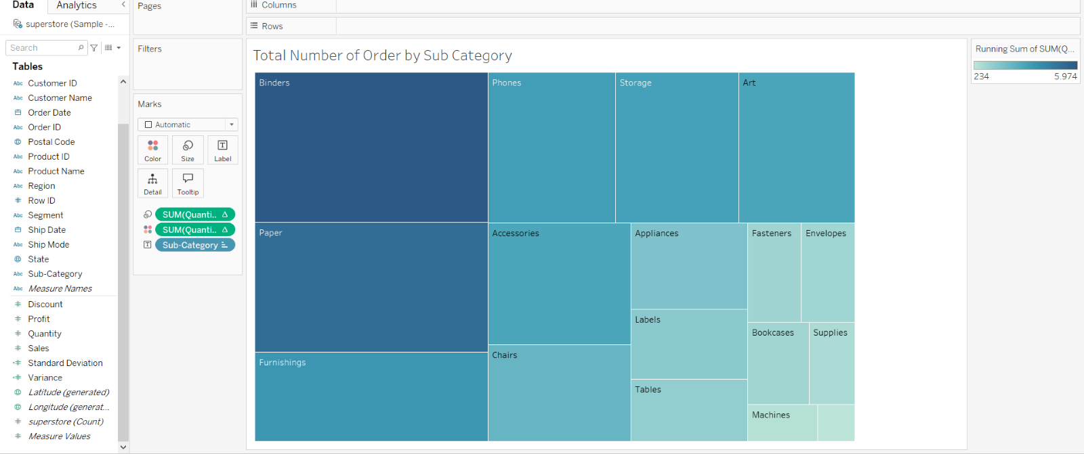Figure 4.2 Total Number of Order by Sub Category

In Figure 4.2 which demonstrates total number of order by sub products via using tree maps and as figure implies darker tone of blue is related higher number of sub categories.

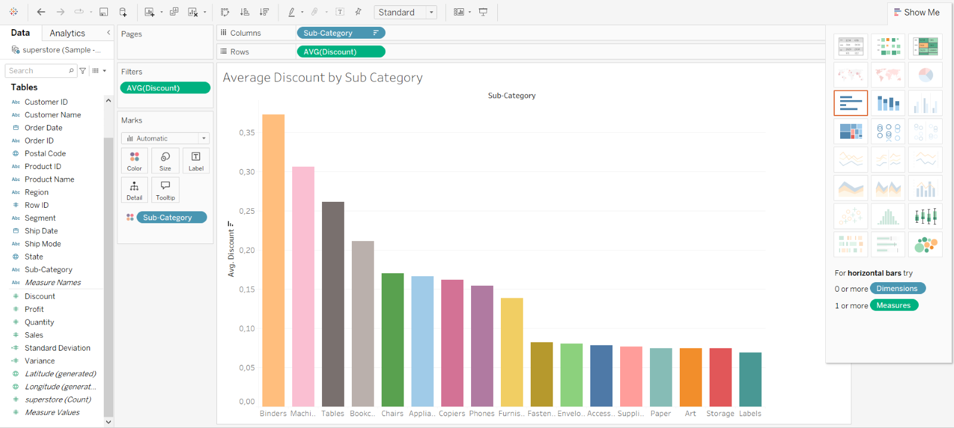Figure 4.3 Average Discounts by Sub Category

In Figure 4.3 which demonstrates average discounts by sub category with using bar chart.In that visualizaiton filter is used to filter between 0.06 and 0.37 based on percentage for making more readable and understandable because discounts lower than 0.06 has no noticeable impact on the analysis.

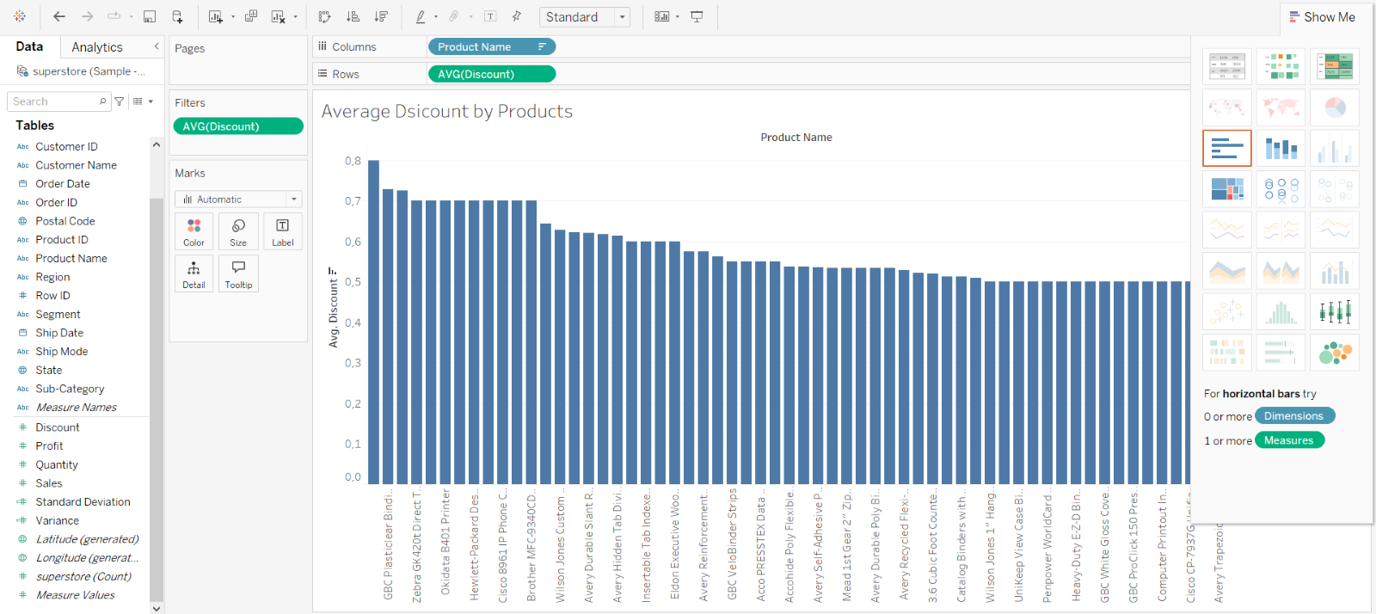Figure 4.4 Average Discounts by Products

In Figure 4.4 which demonstrates average discounts by products with using bar chart.In that visualizaiton filter is used to filter between 0.50 and 0.80 based on percentage.On the other side this visualizaiton can be considered more specific version of analysis which is placed on Figure 4.3.On the other side here the bar graphs is ordered by descending.

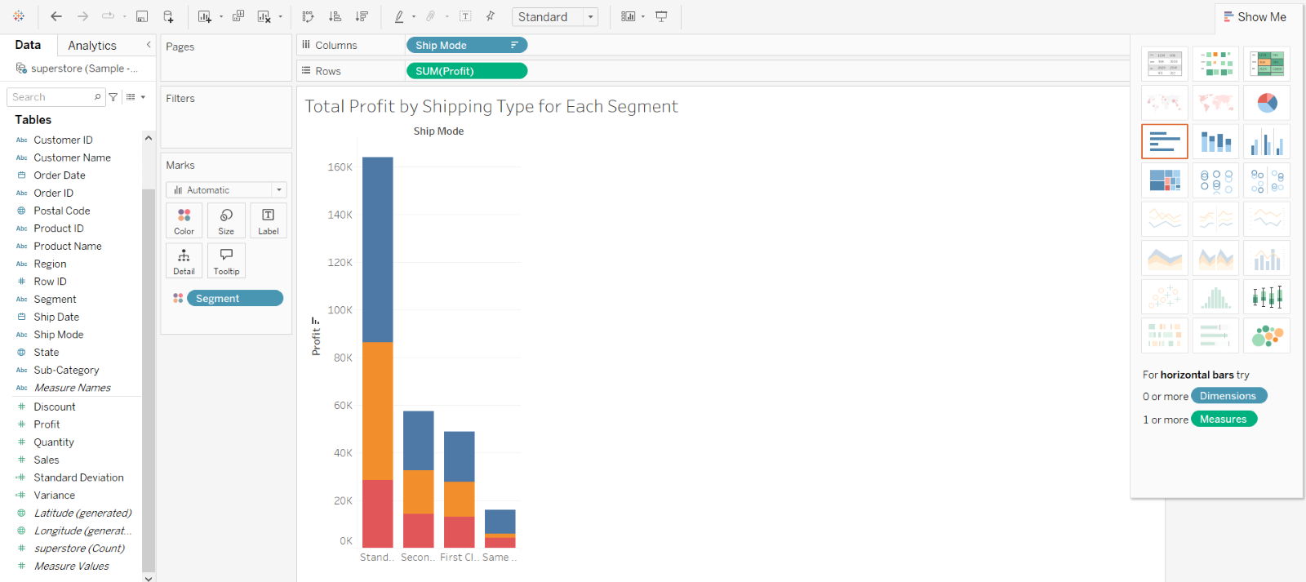  
Figure 4.5 Total Profit by Shipping Mode for Eaach Segment

In Figure 4.5 which demonstrates total profits of salestore according to selected shipping serive for each segment and here mark is used to colour different segments also here the bar graphs is ordered by descending.

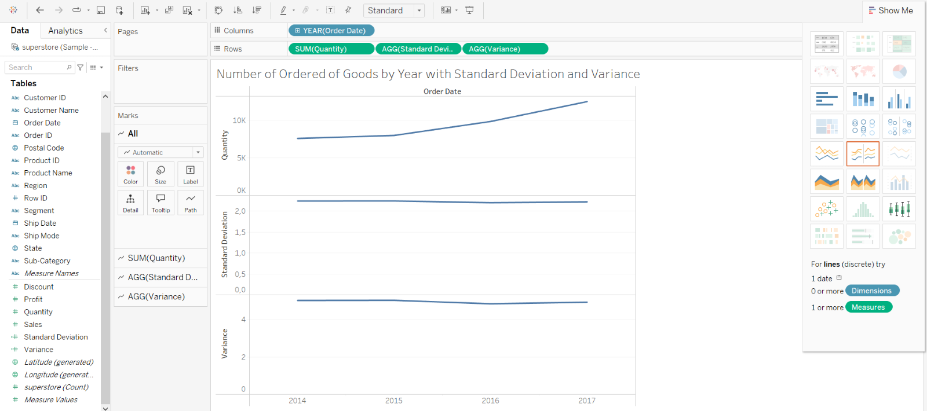  
Figure 4.6 Number of Ordered Goods by Year with Standard Deviation and Variance

In Figure 4.6 which displays number of ordered goods by year with standard deviation and variance with line graph.Here two calculation fields are used STDEV([Quantity]) - VAR([Quantity]) for standar deviation as well as variance respectively.

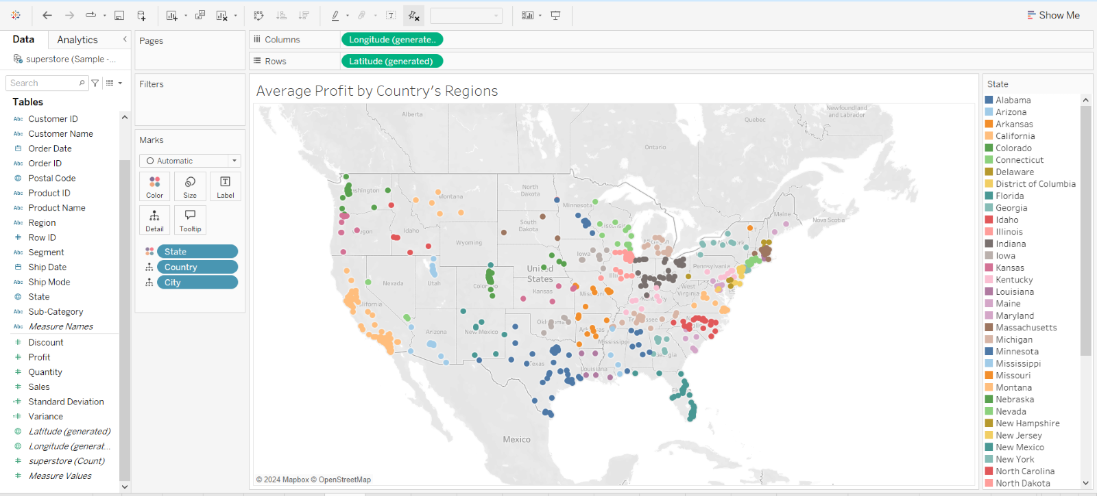  
Figure 4.7 Average Profit by Country’s Region

In Figure 4.7 which shows average profit by country’s regions (states) via utilized symbol maps.Also there are marks are used to make different colurs then these colours categorized by level of average profit.For instance orange colours indicates lower profits on the other side blues are related higher levels.Of course there are sub tones of orange and blue they are for diiferent levels of average profit.

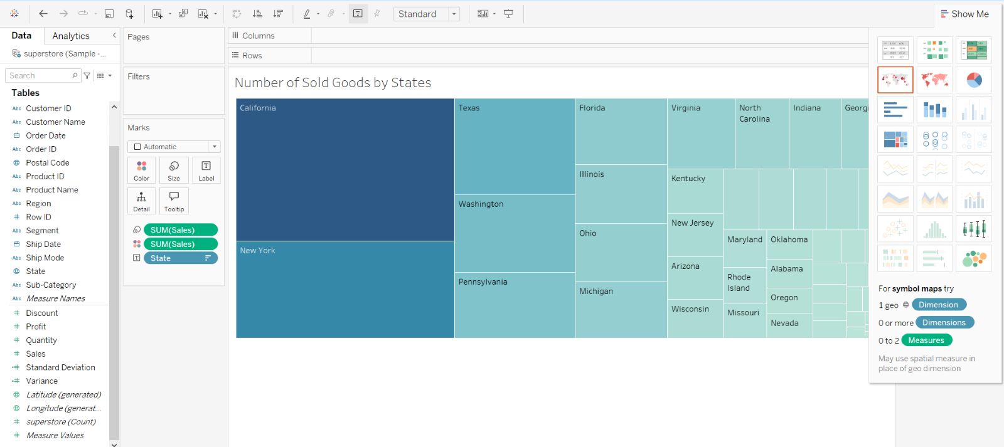Figure 4.8 Number of Sold Goods by States

In Figure 4.8 which displays total number of sold goods by states within the dataset by using treemaps.As the map shows bigger area means that these regions have higher demand among others.

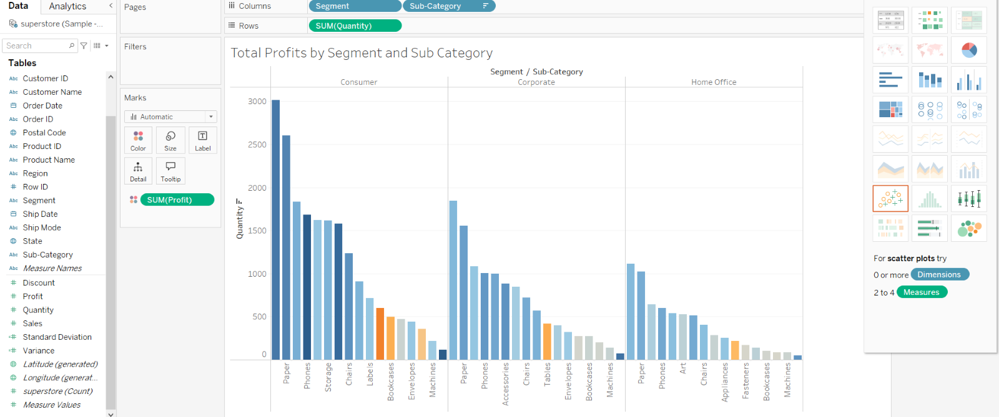Figure 4.9 Total Profits by Segment and Sub Category

In Figure 4.9 which is related to total profits by segment and sub category that is visualized by bar chart at the same time here colour marks are utilized to explain total profit of each sub category across respective segments.As understnad from the visualizaiton descending order feature is enabled.

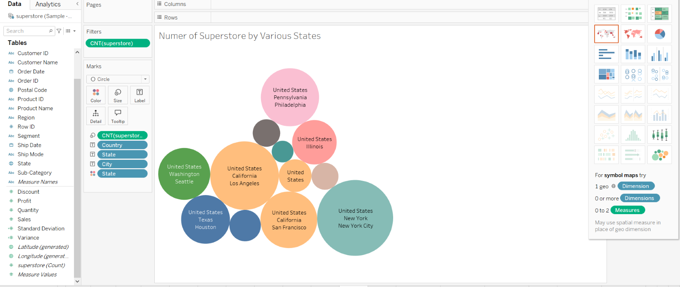Figure 4.10 Total Number of Stores by Various States

In Figure 4.10 which is related to total number of stores across towards to various states by packed bubbles.During the visualization the filter is activated because there too much states also these states don’t have high number of stores so impact isn’t visible and each states are marked by different kind of colours.

## **4.2 Explanation of Dashboards**

Dashboard can be described as summarize of general overview of dataset specific business goals and which contains unify multiple sheets so an analyst can be elobrate analyses throughout more efficient way.In this step sales and financial KPIs will be examined that means from profit situation to price changing of specific products will be explored.

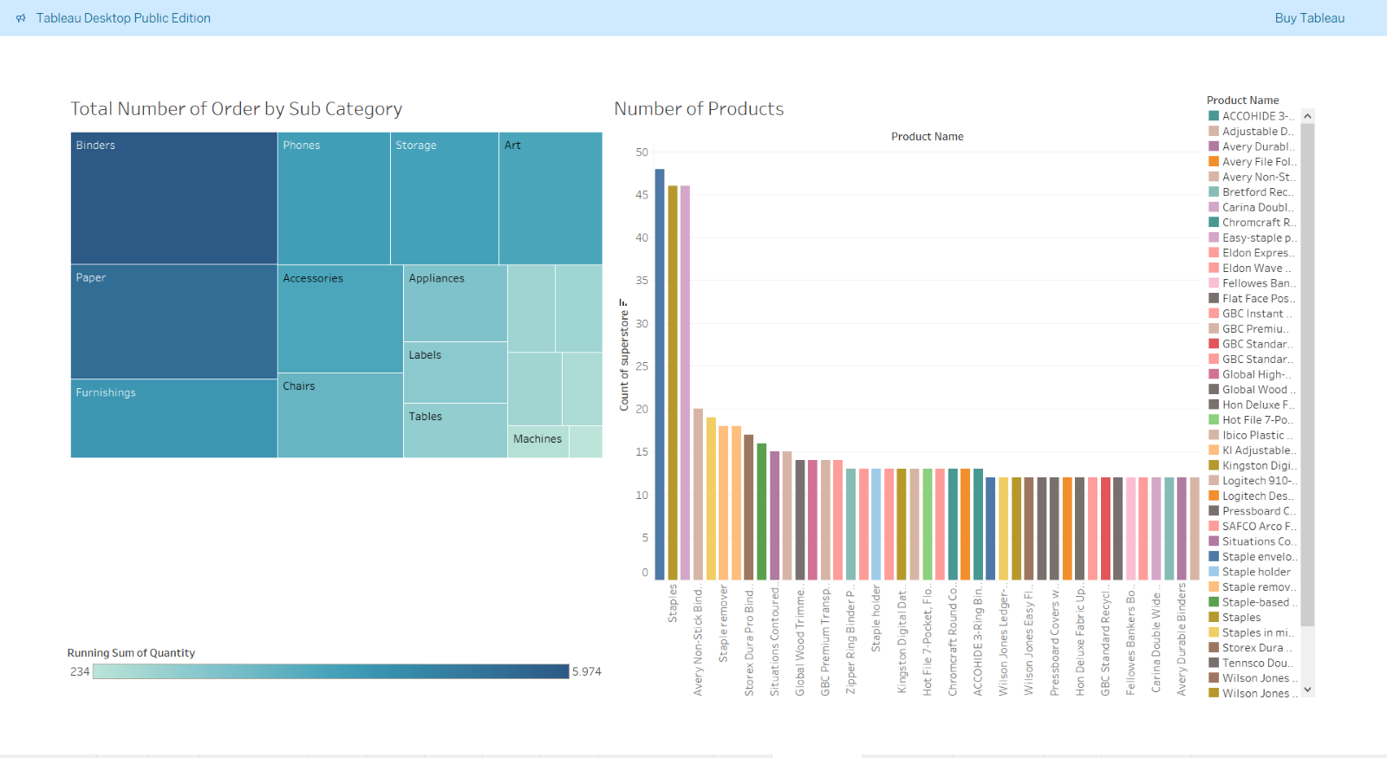 Figure 4.11 Dashboard 1 Number of Order and Products

In Figure 4.11 the first dashboard is related number of order by sub category and number of product of each subcategory.The dashboard is able to elobrate the highest three order belongs to binders , paper and furnishings respectively then on the other side number of sold products on the right side of the dashboard which validates number of orders because first three sold products belong to binder and paper sub category.

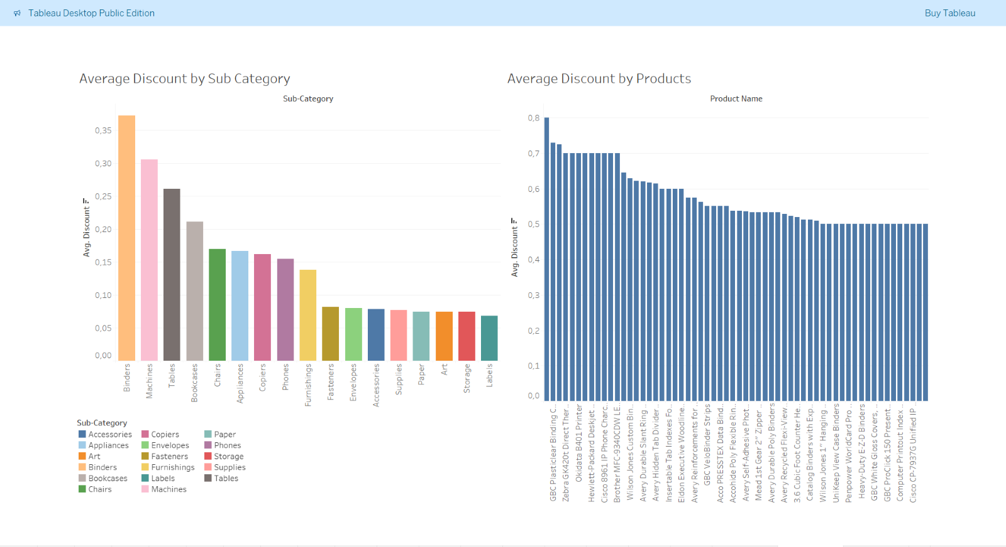  
Figure 4.12 Dashboard 2 Average Discounts Across Sub Category and Products

In Figure 4.12 the second dashboard is related to average discounts towards to sub category and products.About sub category binders , machines and tables have highest average discounts as a result of this situation majority of first five highest discount belongs products of sub categories binders and machine.These highest discounts might be happened on these sub category due to either over left stock or high demand.

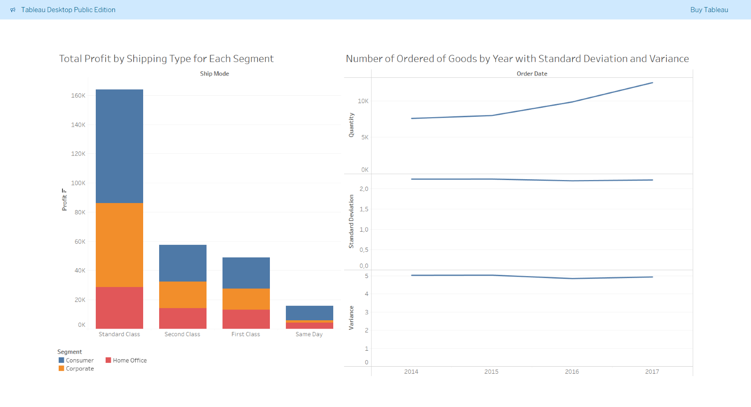

Figure 4.13 Total Profit by Shipping Type and Orders by Year

In Figure 4.13 the third dashboard has information connected to total profits change by shipping type as well as number of order by different years.First of all in the dataset compherensive level of dimesnisons like SEGMENTS > SUB CATEGORY > PRODUCTS then according to the figure highest profits can be obtained when standard class is used other hand lowest profit belongs to same day shipping service because of highest cost.Secondly the dataset is able to proide knowledge between 2014 and 2017 for number of orders.In that case when switch from 2015 to 2016 change of demand is placed on highest level.Also all of this statistical can be observed from standard deviation and variance segment of the line graph.

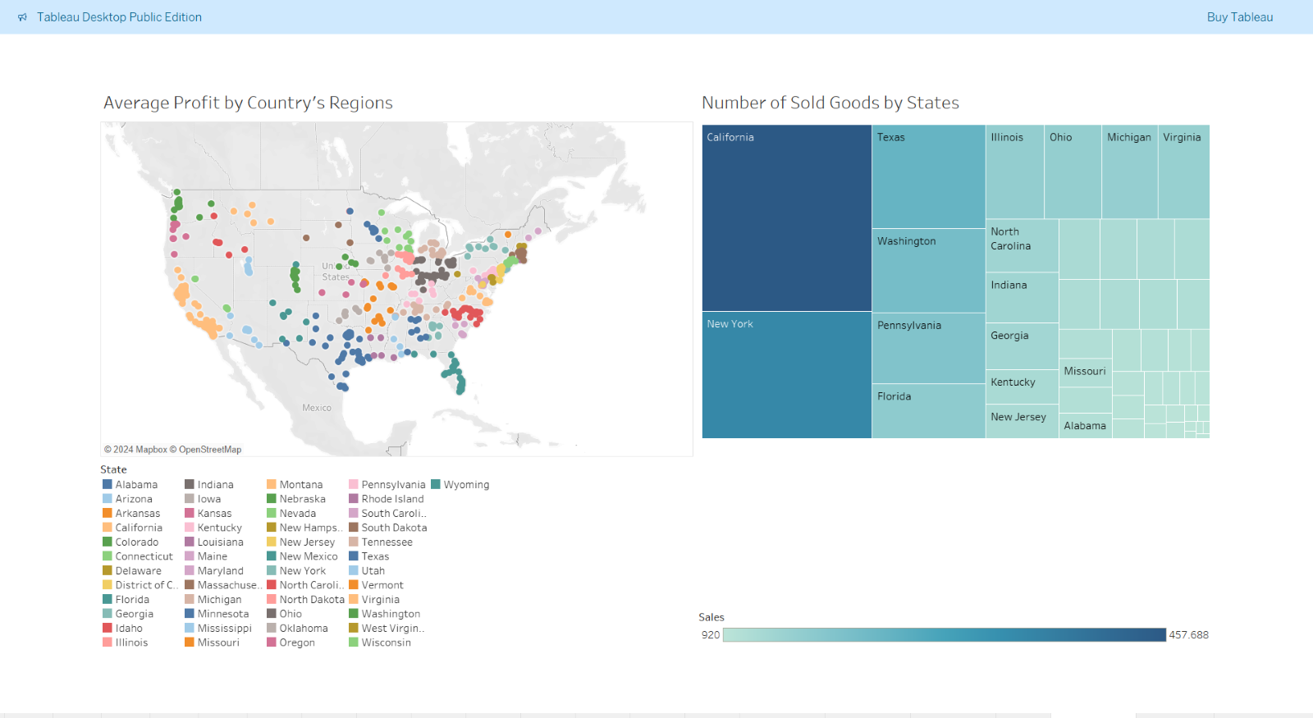Figure 4.14 Average Profit and Number of Sold Goods by States

In Figure 4.14 the fourth dashboard is related to average profit and number of sold goods across different states of United States of America (USA).Actually these two sheets in the dashboard verifies to each other because Califronia has highest demand so highest sold of goods belongs to this state at the sam time this case leads to the highest profit in California.Sociologically California can be classified as high income level in USA so people are able to access more purchasing power so where is ranked at first.Also this is valid for other states.

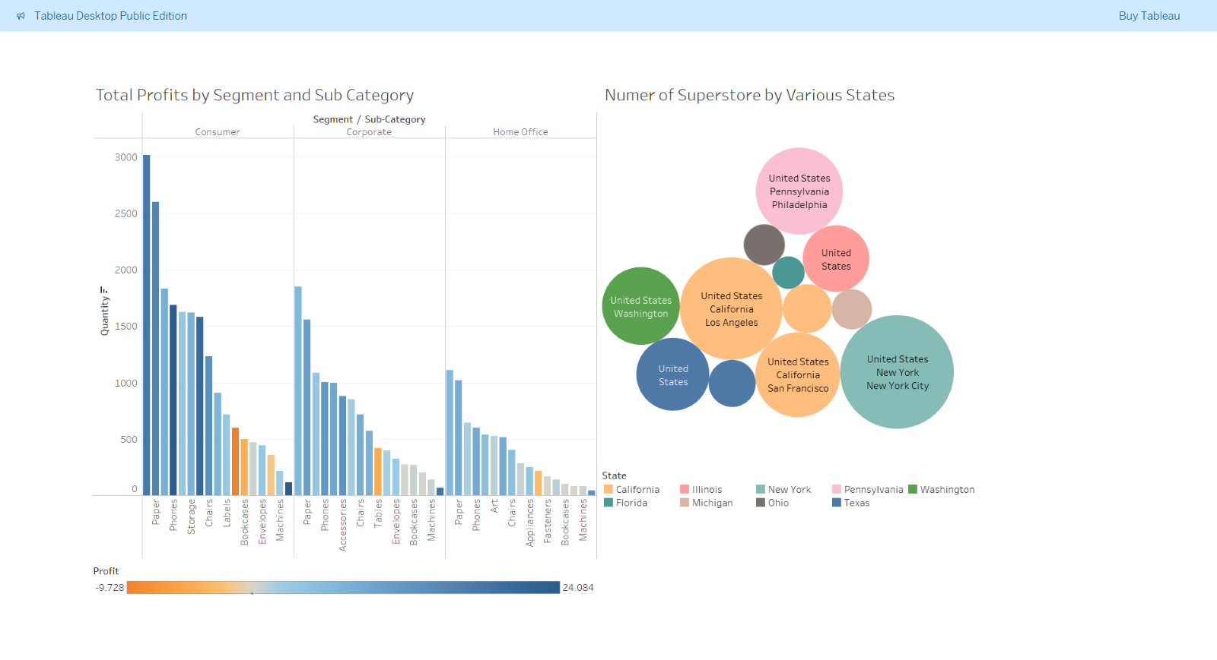  
Figure 4.15 Total Profits by Segment and Number of Superstore by States

In Figure 4.15 the fourth dashboard is able to provide insights total profits by segments with its sub category and number of superstore by states.Among the segments highest profit belongs to standard consumner it is followed by corporate and home office.Moreover within sub category highest total profit has paper for all segments since most probably which is most used product at most frequently this means highest demand.Furthermore between Figure 4.14 and Figure 4.15 there is a positive correlation betwwen number of superstore and number of sold goods which means when California has highest number of sold goods on the other side California has highest superstore branch among other states.This situation is applicable for other place.

# **CONCLUDING REMARKS**

In this study various aspects of business analytics is handled based on theorotical and practical aspects.First of all KPI and its sub types is explianed as well as role of data analyst within in this context.After that possible solutions are listed for selected business study for this study then these solutions compared to each other and end of the day Tableau is selected as a tool.After that technicsl step of each sheets are elobrated before start analysing step.In tthe dasboard part from extracted insight required analyss are elucidated.All of these analyses might be helpful optimizing sales process also for financial stability across the future for the superstore.

Further improvements can be related to if the dataset has information regarding to demographcy feature such as customer age , gender , vacations and so on which would be more benefitical to create marketing KPIs.On the other the dataset some missing points regarding to geographical locations so this situation leads to decrease accuracy analysis based on geographic locations.

# **BIBLIOGRAPHY**

1. Baldwin, Richard. 2016. "The World Trade Organization and the Future of Multilateralism." Journal of Economic Perspectives, 30 (1): 95–116.
2. Dogadina, V. V., & Voronin, A. V. Comparative analysis of data visualization tools.
3. Dubosson‐Torbay, M., Osterwalder, A., & Pigneur, Y. (2002).”E‐business model design, classification, and measurements”. Thunderbird International Business Review, 44(1), 5-23.
4. Gilsing, R., Türetken, O., Grefen, P., Ozkan, B., & Adali, O. E. (2022).”Business model evaluation: a systematic review of methods”. Pacific Asia Journal of the Association of Information Systems, 14(4), 26-61.
5. Heikkilä J, Tyrväinen P, Heikkilä M (2010) “Designing for performance-a technique for business model estimation”. In: Proceedings of EBRF
6. Onadeji,A.(2022)‘SuperstoreSales’,Kaggle <https://www.kaggle.com/datasets/abiodunonadeji/united-state-superstore-sales/data> [Accessed 17 October 2024 ]
7. van de Ven, M., Lara Machado, P., Athanasopoulou, A., Aysolmaz, B., & Turetken, O. (2023). “Key performance indicators for business models: a systematic review and catalog”. Information Systems and e-Business Management, 21(3), 753-794.

# **APPENDIX (if necessary)**

KPIs : Key Performance Indicators

USA : United States of America

WTO : World Trade Organizaiton